Oak Creek Club Homeowners Association
14505 Mary Bowie Parkway
Upper Marlboro MD, 20774
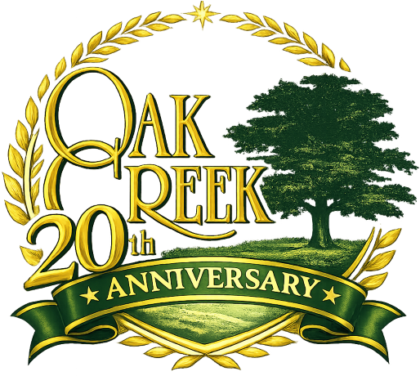

Social Committee Meeting Agenda
April 16, 2026 @6:00 pm

Call To Order: 6:00 pm

Minute Taker: Jennifer Phillips

Resident Forum: 25 minutes

Vote to Approve March 2026 Meeting Minutes

Old Business:
- Discuss Lessons Learned from Easter Event

- Post Save the Dates earlier in hopes of increased participation
  - Metrics: Mother’s Day event reached capacity

- Reminders of upcoming events:
  - 4/17 Bingo 7pm – 8:30pm
  - 4/23 Crochet and Knitting
  - 5/2 Mother’s Day 5/2 o Last minute details sign-ups for volunteers o Setup night before Friday
New Business:
- Discuss details for following events:

o Kids Movie “Swapped” (5/1— 2pm) o Father’s Day (6/14 —TBD) o Oak Creek Day (7/18 —TBD) o White Party (8/5—TBD)
Adjourn Meeting 7:00 pm

