**Oak Creek Social Committee**

**Presents**

**Friday Night BINGO**

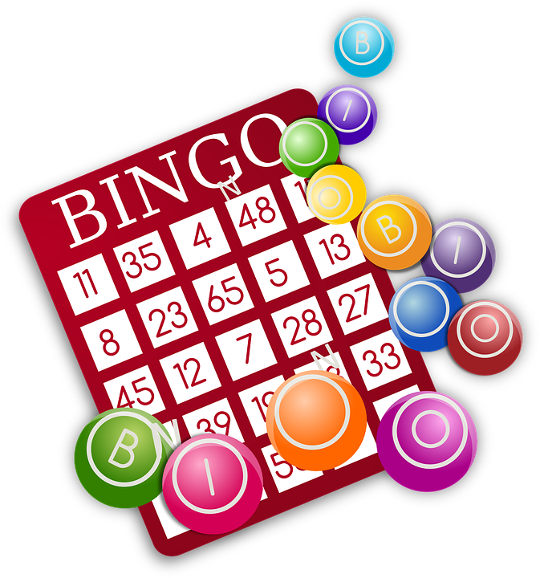

GAMES, FUN, PRIZES

DATE: **Friday, August 25, 2023**

TIME: 7:00 pm – 8:30 pm

LOCATION: SWIM AND TENNIS CENTER

18 years and up

**RSVP by Friday, August 18, 2023**